

# 

### Semester Two Examination, 2016

### Question/Answer Booklet

# MATHEMATICS

If required by your examination administrator, please place your student identification label in this box

**METHODS**

**UNITS 3 AND 4**

## Section One:

## Calculator-free

|  |  |  |  |  |  |  |  |  |
| --- | --- | --- | --- | --- | --- | --- | --- | --- |
| Student Number: In figures |  |  |  |  |  |  |  |  |

In words

Your name

## Time allowed for this section

Reading time before commencing work: five minutes

Working time for section: fifty minutes

## Materials required/recommended for this section

***To be provided by the supervisor***

This Question/Answer Booklet

Formula Sheet

***To be provided by the candidate***

Standard items: pens (blue/black preferred), pencils (including coloured), sharpener, correction fluid/tape, eraser, ruler, highlighters

Special items: nil

## Important note to candidates

No other items may be taken into the examination room. It is **your** responsibility to ensure that you do not have any unauthorised notes or other items of a non-personal nature in the examination room. If you have any unauthorised material with you, hand it to the supervisor **before** reading any further.

## Structure of this paper

|  |  |  |  |  |  |
| --- | --- | --- | --- | --- | --- |
| Section | Number of questions available | Number of questions to be answered | Working  time (minutes) | Marks available | Percentage of exam |
| Section One:  Calculator-free | 7 | 7 | 50 | 52 | 35 |
| Section Two:  Calculator-assumed | 13 | 13 | 100 | 98 | 65 |
|  | | | **Total** | 150 | 100 |

## Instructions to candidates

1. The rules for the conduct of examinations are detailed in the school handbook. Sitting this examination implies that you agree to abide by these rules.

2. Write your answers in this Question/Answer Booklet.

3. You must be careful to confine your response to the specific question asked and to follow any instructions that are specified to a particular question.

4. Spare pages are included at the end of this booklet. They can be used for planning your responses and/or as additional space if required to continue an answer.

* Planning: If you use the spare pages for planning, indicate this clearly at the top of the page.
* Continuing an answer: If you need to use the space to continue an answer, indicate in the original answer space where the answer is continued, i.e. give the page number. Fill in the number of the question that you are continuing to answer at the top of the page.

5. **Show** **all your working clearly**. Your working should be in sufficient detail to allow your answers to be checked readily and for marks to be awarded for reasoning. Incorrect answers given without supporting reasoning cannot be allocated any marks. For any question or part question worth more than two marks, valid working or justification is required to receive full marks. If you repeat any question, ensure that you cancel the answer you do not wish to have marked.

6. It is recommended that you **do not use pencil**, except in diagrams.

7. The Formula Sheet is **not** to be handed in with your Question/Booklet.

Section One: Calculator-free 35% (52 Marks)

This section has**seven (****7)** questions. Answer **all** questions. Write your answers in the spaces provided.

Working time for this section is 50 minutes.

Question 1 (6 marks)

A particle leaves the origin when $t=1$ and moves in a straight line with velocity at any time $t$ seconds, where $t≥1$, given by

$$v\left(t\right)=\frac{t^{2}}{4}+\frac{4}{t}-\frac{7}{4} {\text{ms}}^{-1}$$

(a) Determine the time when the acceleration of the particle is zero. (2 marks)

(b) Determine the exact displacement of the particle from the origin when $t=4$. (4 marks)

Question 2 (7 marks)

(a) Calculate $f'(0)$ when $f\left(x\right)=e^{2x}{\left(1+5x\right)}^{3}$. (3 marks)

(b) Determine $\frac{d}{dx}\int_{x}^{5}{\sqrt{t^{2}+1}}dt$. (2 marks)

(c) Given $f^{'}\left(x\right)={\left(1-2x\right)}^{4}$ and $f\left(1\right)=-1$, determine $f(x)$. (2 marks)

Question 3 (7 marks)

(a) The function $f$ is defined by $f\left(x\right)=\log_{a}{x}$, $x>0$, where $a$ is a constant, $a>1$.

The graphs shown below have equations $y=f\left(x\right)$, $y=f(x+b)$ and $y=f\left(x\right)+c$, where $b$ and $c$ are constants.

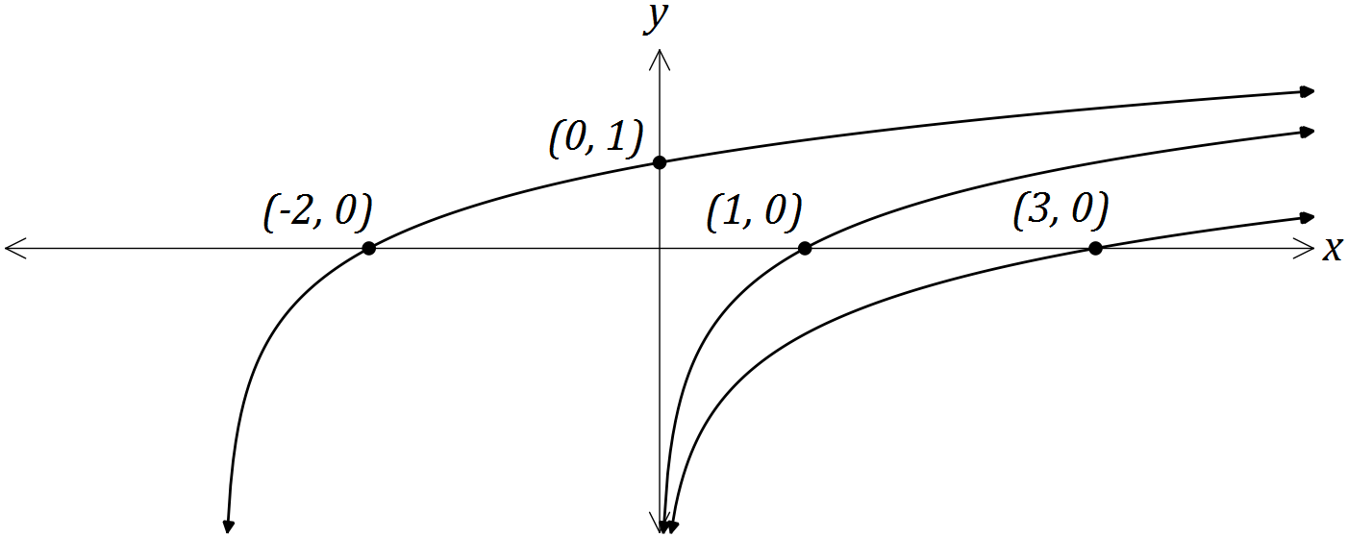

Determine the values of the constants $a$, $b$ and $c$. (4 marks)

(b) Determine

(i) the equation of the asymptote of the graph of $y=\log_{e}\left(x-3\right)-2$. (1 mark)

(ii) the coordinates of the $y$-intercept of the graph of $y=\log_{2}{(x+8)}-5$. (2 marks)

Question 4 (8 marks)

A curve has equation $y=2x^{5}-5x^{4}+10$.

(a) Point A lies on the curve at ($-1, 3)$. Use the increments formula $δy≈\frac{dy}{dx}×δx$ to estimate the $y$-coordinate of point $B$ that has an $x$-coordinate of $-0.99$.

(4 marks)

(b) Point C also lies on the curve, at $(2, -6)$. Verify that C is either a minimum or maximum point of the curve. (4 marks)

Question 5 (8 marks)

(a) Determine the coordinates of the root of the graph of $y=\log_{3}{(2x+1)}-2$. (3 marks)

(b) The graph of $y=e^{2x-1}-4x$ has a single stationary point, as shown on the graph below.

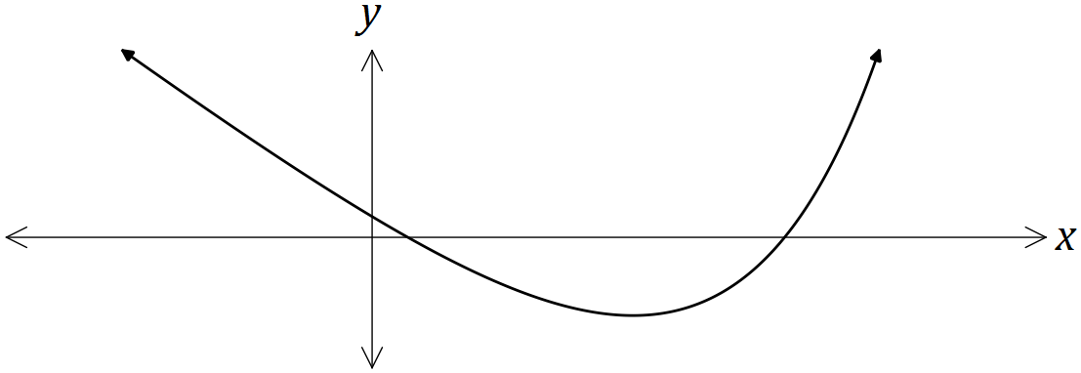

Determine the exact coordinates of the stationary point. (5 marks)

Question 6 (8 marks)

The diagram below shows the curve $y=x^{3}-3x^{2}+k$, where $k$ is a constant. The curve has a turning point on the $x$-axis.

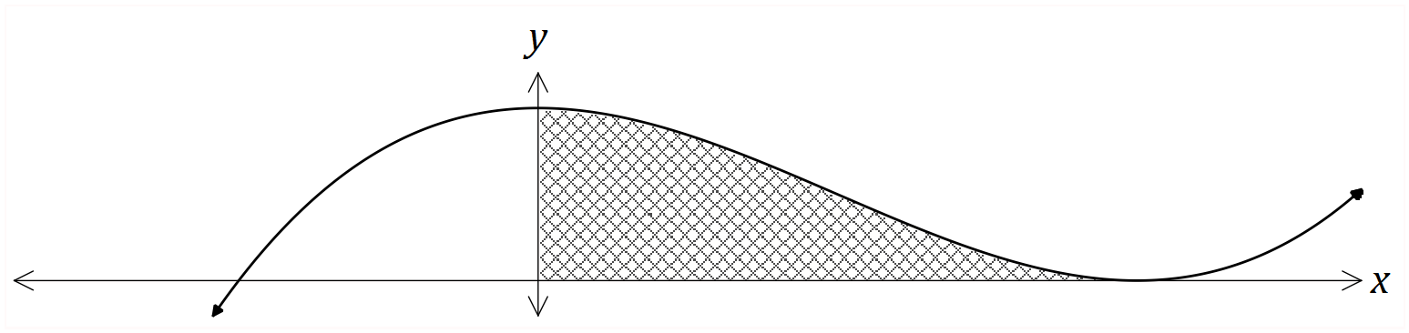

(a) Determine the value of $k$. (3 marks)

(b) Determine the set of values of $x$ for which $\frac{dy}{dx}$ is increasing. (2 marks)

(c) Calculate the area of the shaded region. (3 marks)

Question 7 (8 marks)

The discrete random variable $X$ is defined by $P\left(X=x\right)=k\log{x}$ for $x=2, 5$ and $10$.

(a) Determine the value of $k$. (3 marks)

(b) Determine $P\left(X=2 \right| X<10)$. (2 marks)

(c) $E\left(X\right)=a\left(b+\log{\sqrt{c}}\right)$, where the constants $a$, $b$ and $c$ are prime numbers. Determine the values of $a$, $b$ and $c$. (3 marks)

Additional working space

Question number: _________

Additional working space

Question number: _________

© 2016 WA Exam Papers. Mercedes College has a non-exclusive licence to copy and communicate this paper for non-commercial, educational use within the school. No other copying, communication or use is permitted without the express written permission of WA Exam Papers.